Working of Ultrasonic sensor with Arduino and displaying on Serial Monitor:

**Working:**  We are required to connect ULTRA sonic sensor with Arduino. The pin configuration of Ultrasonic sensor is as follow:

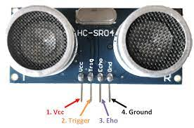

It will be connected to Arduino as following:

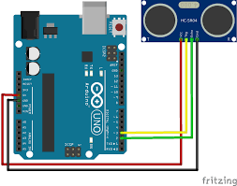

Task later required for an LCD to be interfaced with Arduino and an LED blinking could be added if sensor senses distance above or lower a certain limit.